Museum of WWII Virtual Tour - http://www.museumofworldwarii.com/virtual-tour
Choose a section to learn more about from the list below:

The Holocaust
Pearl Harbor and the American Home Front
The US War Effort
D-Day: The Invasion of Normandy
The Pacific Front
Iwo Jima
Prisoners of War
The Atomic Bomb

Click on the sections you have chosen, and then choose an item. Copy a picture of your item to this document below:

Now find out how that object changed the history of WWII (note: a full paragraph, which means you might need to do a search on Google. ) Type your paragraph below.

Choose one item more and do the same thing as above!

Finally: Choose of one your items and write a historically accurate story based on the object. It should be ½ a page. Example:
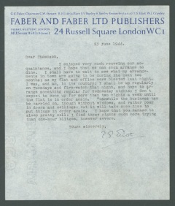
Letter from TS Elliot – Section Everybody’s war.
I was hiding in the tube (subway) near my flat (apartment) and listening to the bombs overhead. I hate those Germans. I’ll never hail Hitler! I hope my girl, Elizabeth across the town is also in the tube… (story continues)

