Throne

Throne
Controller- General

Clergy
Clergy

Clergy
Palace of Versailles
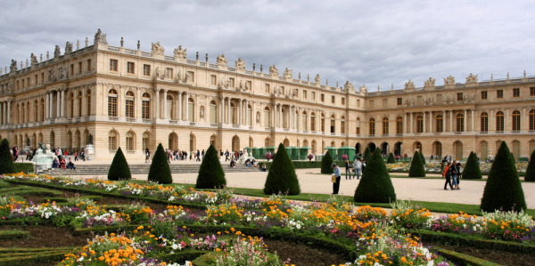
Manor

Manor
Manor

First Estate
Second Estate

Third Estate
Cemetery

