19th Century European Imperialism in Africa

Case Study: Congo

Web Quest

Task I │Task II │ Task III

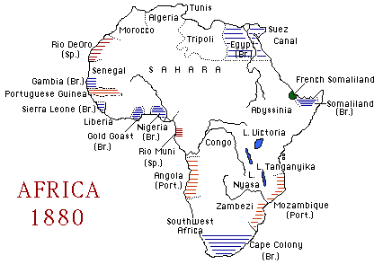

Essential Questions
- What were the goals of 19th European imperialism for Africa?
- How were those goals realized by King Leopold II of Belgium in the Congo?

Task I

1. For a general review of European imperialism in the 19th century, visit
the following website.

http://crh.choate.edu/worldtech/fosterclassB/MAGauntt/Page2.htm

2. Visit the following website: http://www.refdesk.com/.
Differentiate between the following terms: colonization, imperialism.

- Visit the following website to view the extent of colonial empires in the world of 1914. Write one statement that summarizes the map in view.

http://users.erols.com/mwhite28/1907powr.htm

Task II

- Answer the following questions after visiting the websites listed below.
  - What were the main causes of European colonization of Africa in the nineteenth century?
  - How did European imperialists justify their return to Africa as colonizers?
Modern Africa: The Roots of Colonialism
http://www.wsu.edu:8000/~dee/MODAFRCA/MODAFRCA.HTM

Map of Africa as a colonized continent- note any changes after WWI
http://occawlonline.pearsoned.com/bookbind/pubbooks/brummett_awl/chapter32/medialib/thumbs/ch32_874.html
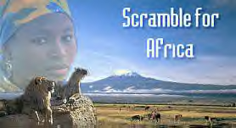
5. Investigate the Berlin Conference of 1884 by visiting the following web sites. Then answer the questions.

  - Who was involved in the planning of the conference and why?
  - What was the ultimate purpose of the conference?
  - How did this conference impact colonialism in Africa?

“ Conference host Otto von Bismarck—the “Iron Chancellor” of the German Empire—famously declared: ‘My map of Africa lies in Europe.’ ”

Berlin Conference
http://www.campus.northpark.edu/history/WebChron/Africa/BerlinConf.html
http://www.africana.com/Articles/tt_473.htm
Modern Africa: The Scramble for Africa
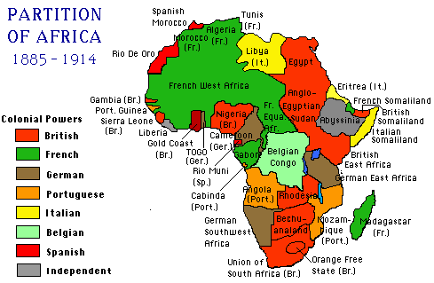 http://www.wsu.edu:8000/~dee/MODAFRCA/MODAFRCA.HTM
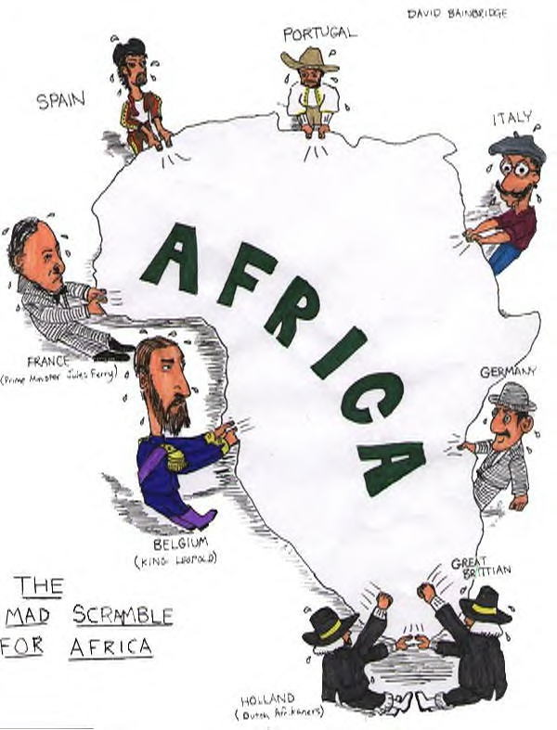

Task III

5. Write a brief essay about the country of the Congo as a case study of European imperialism in Africa in the 1800s by visiting the web sites to answer the following questions.

- In the time period, 1750 to 1914, who colonized this country, why and when?
- Compare and contrast conditions in the Congo (Kongo) during the time period 1450 to 1750 with conditions in the Congo, 1750 to 1914.
- What effects did colonialism have on this country? (Cite specific political, economic and social examples.)
- In what ways did the country react to colonization? (Cite specific examples.) How did the world react to hearing of atrocities committed within this colony?
- Predict the potential problems to be faced by this Belgian colony in the wake of independence and self-rule.

http://www.hartford-hwp.com/archives/35/181.html

http://www.wsws.org/articles/1999/sep1999/king-s06.shtml

http://www.edenpr.k12.mn.us/ephs/Conrad/Congo.html
http://www.homeusers.prestel.co.uk/littleton/brfobcon.htm

http://www.hartford-hwp.com/archives/35/073.html

http://www.historywiz.com/leopold.htm

http://www.boondocksnet.com/congo/

http://www.internationalist.org/USgodfather.html

http://wombat.cusd.chico.k12.ca.us/~bsilva/projects/scramble/leopold.htm

CIA – The World Factbook 2001 – The Democratic Republic of the Congo
http://www.odci.gov/cia/publications/factbook/geos/cg.html

Congo 2000 Web Site
http://www.congo2000.com/english/enpage.html

Return to the top

