Please go the following website: http://edsitement.neh.gov/lesson-plan/lesson-2-trekking-timbuktu-trade-ancient-west-africa-student-version#sect-activities

Activity 1. The Salt Mines of the Sahara
Hitch up your camels and get on your way. Make sure you've got plenty of water. You'll need some long pieces of cloth to wrap around your head as protection against the sun and wind. And bring along some warm clothing - it's hot in the desert in the daytime, but it gets very cold at night. From Sijilmasa, you head south. Your first stop will be the salt mines of Targhaza.

The main stopping point of caravans moving south across the desert was the salt mines of Targhaza. In this activity, students will find out how the salt was obtained and why it was so important in the West African trade networks.

1 . Access Trans-Saharan Gold Trade. Find Sijilmasa, Targhaza, and Timbuktu and label on the map provided:
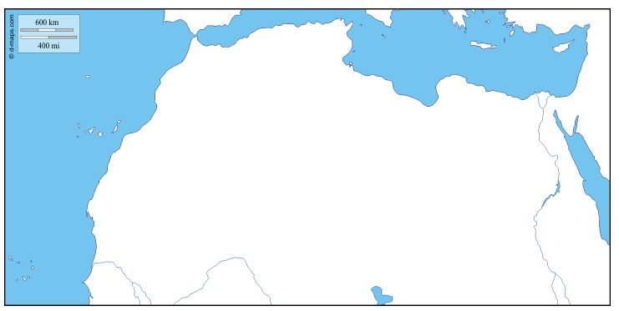
- Go to The Topic: Salt. What are the main uses of salt? After answering the previous question please pick one of the links under 4Xexplorer to read on your own. Write a summary of what you learn in the space provided.

Summary:

- Access Saharan Salt Trade. What are two ways of obtaining salt in the Sahara?

- Now go to Salt-hauling camel trains. Scroll down to “Biblical Scene.” Who mined the salt in ancient times?

Activity 2. Ghana Corners the Gold Market
The salt that was brought down from the Sahara was usually traded for gold. The gold was mined in the forests of Guinea, near the source of the Niger, and carried downstream to the markets along the Niger in dugout canoes. Many local merchants became quite wealthy. Ghana, West Africa's first kingdom, depended upon income from trade. It became so rich it was known as the Land of Gold.
Your caravan has made it to the edge of the Sahara and is setting up camp at a trading site along the Niger River. All that salt you collected in Targhaza is worth a great deal here in West Africa. In fact, it's worth its weight in gold!
- Access the Map of salt and gold mines. These are the major salt mines (near Targhaza) and the gold mines (in the regions of the upper Niger). Return to Trans-Saharan Gold Trade. Locate the gold mines and the salt mines. Please label all of this on the map provided on the first page of this webquest.

- Go to Ghana Empire. After reading the text, click on the map to enlarge it. What are some of the other products traded in Ghana? Jot them down in the space below. How did the ruler of Ghana make a big profit?
As king of the Land of Gold, Ghana’s ruler made certain that he looked the part.
- Access Ancient Ghana. Scroll to the box entitled Royalty Gorgeously Attired. Click on the audio and listen to a description of the king and his court as recorded by an Arabic visitor. In the space provided sketch what Ghanese ruler would look like:

Activity 3. Muslim Merchants Flock to Mali
The expansion of Islam across North Africa in the 7th century led to a great increase in West African commercial activities, as Muslim merchants became actively involved in the trans-Saharan trade routes.

You've finished bargaining with the gold traders. But before you head back north, you decide to take some time to visit with a few of the other Muslim merchants traveling in your caravan. But before you begin chatting, you'd better find out a little bit about their religion, Islam, and how it spread to Africa.

- Access Islam.
Define the words Islam
Define the words Muslim
Who was Muhammed?
What is the Qur'an?
What is a mosque?
Where is Mecca, and what is its importance to Islam?

- Now go to The Birth of Islam.
What does the word Qur'an mean?
What are the teachings of the Qur'an?
What is the Ka'ba? Who were the caliphs?
In what direction did Islam first expand from Arabia?

- Go to Trans-Saharan Gold Trade. Read the first section: Gold Trade and the Kingdom of Ancient Ghana. Why did people in the north want the African gold?

- Return to Ancient Ghana. Scroll down to the sections entitled Islam and Muslims in Africa.
Did Islam coexist peacefully with local tribal religions?
How do you think Muslims in other parts of the world might have thought about
this?
Could there have been pressure for the African rulers to convert?

Location Scouting Summary: Trading Places
You are in a market in ancient Ghana, surrounded by merchants, local inhabitants, and snorting camels.This is a fascinating place—something viewers back home really need to learn about! How can you convey a sense the excitement—the sounds, smells, and images of ancient Ghana—to the producers of Globe Trekkers? On a separate sheet of paper write the stage directions for a reality show to be taped at this setting.

